Emily West

[Westemi@oregonstate.edu](mailto:Westemi@oregonstate.edu)

Richer Worlds for Next Gen Games: Data Amplification Techniques Survey

Final Paper Analysis

The presentation titled, “Richer Worlds for Next Gen Games: Data Amplification Techniques Survey” looks to discuss the issues in current games, and how techniques can be amplified or used to create more diverse worlds in games, without sacrificing too much data, time, or money. The world in a game is one of the most vital aspects to a game’s success and can often be the most challenging. The main problem is how current games are being made, with too much strain on the CPU, without utilizing the fast speeds and power of the GPU. This is the main theme of the presentation, that the GPU is currently underutilized, and should be used more in games to create richer worlds. The author wants to provide interesting techniques to make better games, and as a result a better gaming industry.

The presentation was authored by Natalya Tatarchuk. The presentation is listed under ATI research inc., a small research group from Austin, TX, where Natalya led multiple research teams. The research was presented at Game Developers Conference Europe in 2005. Natalya Tatarchuk has a B.A. in Mathematics and Computer Science from Boston University, as well as an M.S. in Computer Science from Harvard. She has worked for Bungie on Halo and Destiny, as well as the VP of graphics for Unity, leading the graphics team. Later she became a Distinguished Technical Fellow and Chief Architect, VP, Wētā Tools at Unity, and just recently became a CTO at Activision. She participates regularly at SIGGRAPH and seems to have a deep understanding and love for computer graphics.

The first main topic in the presentation is data amplification, which is defined as creating complex images from small datasets. The idea behind this is “If you can generate it, an artist doesn’t have to build it.” This idea is great, since it does save the company a lot of resources, like time and money. The creation of content is one of the main factors slowing down production of a game. This leads into the next topic, procedural data generation. Procedural data generation can mean a multitude of things, ranging from textures, plants, geometry synthesis, and even into the 3d world. We now see procedural generation in a lot of games, especially games that are meant to be replayed over and over again, like Minecraft or Lethal Company. Natalya even gave examples for procedural textures, like clouds or water with added noise, but with the idea of synthesizing new data from video. The ability to take real footage and turn it into new and unique outputs for the game.

The next main topic is geometry amplification. This technique wants to amplify geometry using synthesis and instancing. The author says it would be much faster to generate geometry or animations instead of storing them in memory. It is really slow to access memory, especially for large features, but it is also slow to create real-time simulation. She suggests two approaches, one which can change the phase of a wave in a water animation, much like the ripples we made in an assignment. Another option is to synthesize height fields and apply that to the water, to displace it vertically. The main point of this technique is to utilize the GPU, where both of these computations should be performed. The next portion is instancing, where there can be a single source model that is used multiple times. You can then used shaders to make the objects more diverse, instead of looking all exactly the same. When this is applied with a few more source models, the scene can become very diverse with much less computation time.

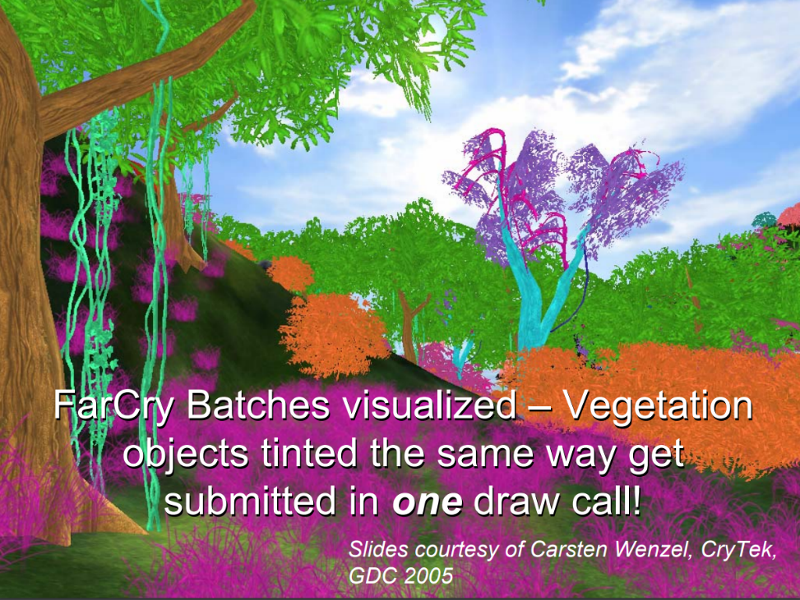

The next topic is data streaming. The problem arises when there are big datasets of art assets, then it is time consuming to get them to the GPU for rendering. She suggests using progressive buffers as a new rendering method, which can reduce the number of draw calls. The method of loading levels while players are finishing the current one is used a lot today, I have even seen indie developers who go as far as loading in each non-player character that is used in the game on startup, so that no loading of characters needs to be done during play, they just get moved to a visible area when ready. There are some drawbacks to this technique, including limitations of data structures and memory usage.

This leaves us with the last topic, data simplification. The goal is to render details surfaces and objects, without having too many triangles and having the render be accurate. The first solution is parallax occlusion mapping, which is described by Natalya as “Per-pixel ray tracing at its core”. She goes into great detail about the implementation of this technique, and the outcome is a detailed, and fairly accurate version of an object with significantly less triangles in the geometry. This mapping technique is also produced in real-time, and can be used with lighting as well.

The conclusions of this paper draw that the gaming industry is so extremely diverse. The stories are so rich, and the graphics deserve to be even richer. There are so many thoughtful and unique methods to some just as unique problems. Computer graphics is a challenging but rewarding field in computer science, and there are so many creative people creating solutions. This was presented in 2005, and we are still seeing these methods being used, as well as some of the same problems. The CPU will most likely always be slower than the GPU, making the GPU so valuable to games. The graphics in games continues to grow and get better, and I don’t see it slowing down anytime soon.

I gained a lot of new knowledge and insights from this paper that I did not already know. I knew some of these techniques existed, but it was interesting to see the perspective of them from 2005, especially from someone who seems to be at the top of computer graphics. I appreciated seeing some connections to my favorite games, and especially some connections to some homework assignments that we have done as well. There are so many ways to create a solution for a problem and computer graphics really has the most diverse solutions.

One of the main flaws that I saw in the presentation was the use of procedural generation and data amplification to work around having more artists. This is a huge topic currently, with the increase of people using AI, especially for artwork. It is much faster and money-saving to have AI or other techniques create art for you, but it is also lacking in creativity and uniqueness. I find that procedurally generated art can sometimes feel boring and repetitive, unless it is used in the correct way. It would be nice to have a balance between the two, a way to increase the productivity of the artist, without sacrificing the human touch to the diverse art. It would be interesting to see what her thoughts are on AI, and I am sure that I will continue to research her work and see if I can find anything.

It is hard to say what I would do next, especially since we have seen the evolution of the game industry over the last 20 years. I think that creating incredibly rich worlds in game is very important and can make a lasting impact on the player. I definitely am a big fan of when a game looks really good. I also think it is interesting that we are seeing so many different types of games becoming popular, and I don’t think the main focus is the graphics anymore. When I was growing up, the most popular games were always the ones that looked the best, especially once flat screen TVs and more powerful consoles and computers came out. But recently I feel we have started to notice a shift, since it is almost too easy to get a game to look good enough. Some popular games currently are extremely graphics heavy, like Baldur’s Gate III or Elden Ring. But there are also some recently popular games like Among us and Lethal Company, where the focus is more on the entertainment of the playstyle of the game. I think if I were creating a game, I would try to create a bridge between these two different worlds, where the game can be aesthetically pleasing and also have the quick-paced playstyle of the sillier, less graphics focused games.

If I were to continue the research, I would try to find ways to use less memory. I find that when I am playing games, they require so much space in memory. This results in many games needing to be stored in external hard drives, which makes them much slower and more consuming of resources. I think it is important to always try to find ways to keep memory cost low, so that the end user can have the best product possible.

The presentation was a beautiful display of computer graphics craftsmanship. The connections to some popular games and methods that they used was very interesting. The research presented is very extensive and creates a lot of special solutions to computer graphics problems. The game industry is very complex, but it continues to grow and improve in unique ways.